Socio-informatics and argumentation

argumentative sociology of socio-informatics controversies, concepts and methods
Skip to content
- HOME
- ABOUT

- WRITING
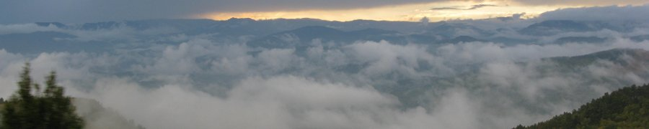

Theories of complexity: benchmarks
1 answer

Fabrizio Li Vigni1
For about thirty years, the term "complexity" has imposed itself in the discourse of researchers and intellectuals, research institutes and scientific journalists. Many researchers, whatever their discipline, are interested in it. Multiple, with uncertain outlines, the theories of “complexity” cultivate and nourish the hope of arriving at new solutions, sometimes considered “miraculous”, to social and environmental problems; they can also produce a kind of wonder, or at least cognitive excitement, by opening up the real and deep understanding of so-called complex systems.
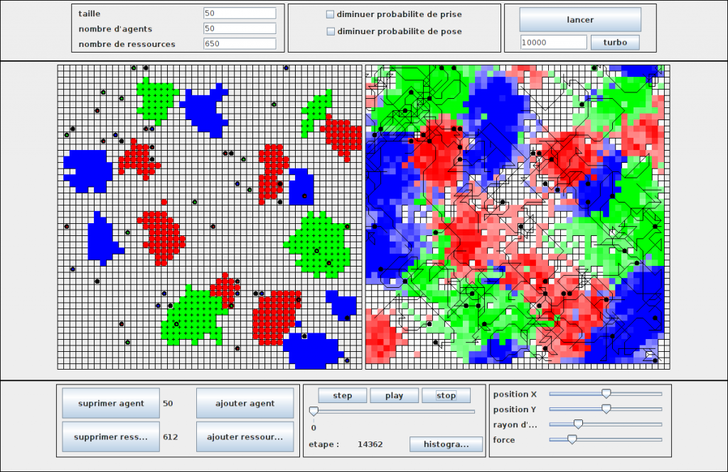
Multi-agent systems (tradition of dynamic systems and networks)
This still little studied field leads the social science researcher to ask himself a series of questions 2 . Why, for example, have confirmed scientists wanted to create new research spaces, or even produce a scientific or epistemological “revolution”? In what way did their original disciplines and research institutes not satisfy them? How are the actors of complexity linked to the important organizations that finance them from digital, i.e. virtual models?? What is, more generally, the role that the computer plays in the modeling of complexity, given the ambition to capture the “real” world? From a philosophical point of view, is the domain of complexity really anti-reductionist? In other words, what epistemologies emerge from official discourses and observable practices? Do they coincide? Finally, can complexity theories, in their diversity, really help in the management of world affairs? With what risks and what benefits? In other words, what are their promises and what has happened to this day? To answer these questions, ethnographic work, interviews and archives have been initiated and will be continued over the next few years. However, these questions have little chance of being answered if one does not clearly establish, beforehand, the perimeter of the actors and the ideas in play. The fact that these questions find different answers according to the actors can then make the difference. subject of more precise investigations. From an exploratory work3, which serves as a support for this post, we precisely sought to establish this perimeter of actors, in order to question the supposed unity of the domain of complexity. Is there a homogeneous, solid and universally recognized area of ​​complexity? The answer turned out to be negative and we spotted three major groups, sometimes in conflict with each other. This is already a good starting point for examining the field of complexity theories.
In the absence of large-scale sociohistorical work on this disparate field of research, its main analysts are often scientists or thinkers who are also its protagonists. For example, the American mathematician Ralph Abraham proposed a homogeneous and unitary vision of this field of research, of which he is himself a recognized representative 4. Abraham locates the roots in cybernetics, systems and mathematics of dynamical systems, and defends the hypothesis that these theories unified from the 1970s.

Three theories on a chalkboard
Cybernetics is an approach created in the United States in the 1940s by scientists, mainly mathematicians and engineers, the best known of which are Norbert Wiener and Warren McCulloch 5. It is based on the concept of feedback , that is to say the ability of a dynamic system to modify its behavior on the basis of data received from the environment or from its own internal process.
Systemics is an approach that was also developed in the United States between the 1930s and the 1950s, following the efforts of a biologist and philosopher of Austrian origin, Ludwig von Bertalanffy 6. It sets itself the goal of implementing a set of mathematical formulas capable of describing all living and social systems, despite their differences.
Finally, dynamic systems theory, whose foundations were laid by the French mathematician Henri Poincaré at the end of the XIX ^{th} century, is made of a coherent area in the 1960s and 1970s through the chaos theory 7.
Despite these multiple theoretical roots, for Abraham and others in his field, there is only one science of complexity. However, our historical and sociological research shows that the panorama is far from being as homogeneous and integrated; moreover other actors, excluded by Abraham, claim to be in this field and indeed have strong interactions with the other actors who compose it.
When you ask not only scientists but the general public what complexity is, you get many different answers. Each appoints a researcher or a research center who, more than the others, would embody the concept of complexity. Some give the name of Niklas Luhmann, others that of Edgar Morin, still others that of the American Santa Fe Institute or of the Center for Complex Network Research of Albert-László Barabási; still others refer to Herbert Simon, Ilya Prigogine or Stephen Wolfram. Who is right ? Everyone and no one. All of them, because these researchers and centers, along with many others, participate in theories of complexity. No one, because the domain in question cannot be reduced to a single name or a single acronym.

Definitional exercises
Such a finding does not prevent us from being able to propose, in a provisional and generic way, a definition encompassing all the main actors claiming to be in this field. By seeking to identify only the features in common and leaving aside the points of divergence, complexity theories can be defined as a very varied body of knowledge which, with tools, epistemological frameworks and languages ​​which differ greatly between groups and even among researchers, propose to tackle the problems of irreducibility, unpredictability and randomness . This definition was not given to us a priori : it is the result of a sociohistorical work on the actors, from a bibliographical analysis, but also through the realization of interviews, ethnographies and examination of archives.
If we have chosen the formula of “theories of complexity”, it is because it seems generic enough to us to include very different figures. By "theory", we refer as much to a philosophical doctrine as to a science. While "complexity" sometimes refers to philosophical discourse on the concept in general, sometimes to scientific studies on complex systems.
The very terms of “complexity” and “complex systems” remain to be defined, once again in a generic manner. If in common language "complex" is synonymous with difficult, obscure, entangled, the etymology indicates two very precise characteristics: the first is the interdependence between the components of a set and the second is the irreducibility of this set to its parts. The actors in complexity theories do not refer to the common language but to the Latin etymology of the term: cum and plexusmean "with" and "fabric" respectively. Therefore, everything that is woven together and that cannot be decomposed without being denatured is complex. It is the most philosophical authors who reflect on the epistemological origin of the term, although the most scientific actors are not unaware of it. The latter, however, prefer to speak of complex systems, which can be defined as integrated sets composed of a large number of interacting components, results of evolutionary processes and endowed with emerging properties, in the sense that the microscopic level generates a macroscopic organization which is not predictable from the constituents.
Our research has convinced us that, within the realm of complexity theories, there are three major groups: one which refers to von Bertalanffy systemic and Wiener's cybernetics; another which refers to the mathematics of dynamic systems of Poincaré and the theory of networks of the Hungarian physicist Barabási (among others); finally a last group which refers to the theory of algorithmic complexity of the Russian mathematician Andrei Kolmogorov (theory in which, according to Abraham, the term of complexity is just a "coincidence of terms" with complexity as understood by first two groups 8).

A first group - algorithmic complexity
The group inspired by Kolmogorov is a group made up of few researchers, especially mathematicians and computer scientists, who are working on a very precise definition of what a complex algorithm is. If a set of numbers is expressible with a short formula, we say that this set of numbers has low algorithmic complexity. If a set of numbers cannot be synthesized by a shorter formula, we say that this set is random, i.e. it has a higher level of complexity. Researchers who reason on these concepts generally do so to find applications in computer science or biology 9. Research centers or journals entirely dedicated to this approach do not exist. This is the most modest and marginal group, whose most active and well-known representatives, including to the general public, are Jean-Paul Delahaye and Serge Grigorieff, based respectively in Lille and Paris 10.
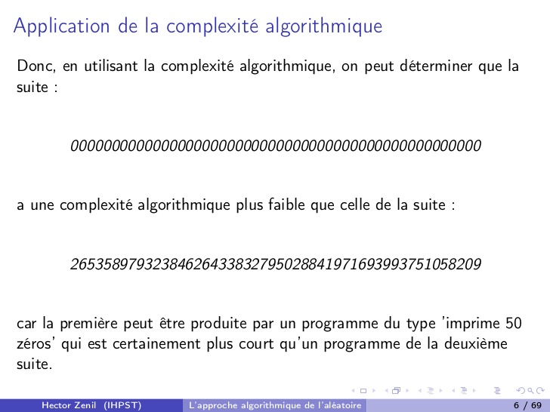
Algorithmic complexity (homonymous tradition)

A second group - a science of dynamic networks
The group that calls itself the mathematics of dynamic systems and the theory of networks is a disparate group, made up of physicists, mathematicians, computer scientists, engineers, biologists, immunologists, neurologists, sociologists and urban planners. It is less coherent than the first group, but more than the last that we will deal with because, despite the variety of disciplines and tools involved, it still has a set of instruments and conceptual approaches that have been relatively stable for a long time. thirty years, as well as research centers and dedicated journals, both in the United States and in Europe. The first such center, the Santa Fe Institute, was founded in 1984 in the United States 11. Since then, the researchers who make up this community have mainly operated through mathematical and virtual computer models, in an attempt to simulate complex natural and human systems, from cell to brain, to cities. For ten years, funding directed towards this research has increased, worldwide, in proportion to the ambition of the promises and hopes that they advance and arouse. Their objective is not, in fact, only one to understand and describe more adequately complex systems, but also to anticipate and manage better 12. The most important representative in France of this group is the Institut des Systèmes Complexes - Paris Île de France, founded in Paris in 2005 by the polytechnician Paul Bourgine and other scientists, united in the National Network of Complex Systems .
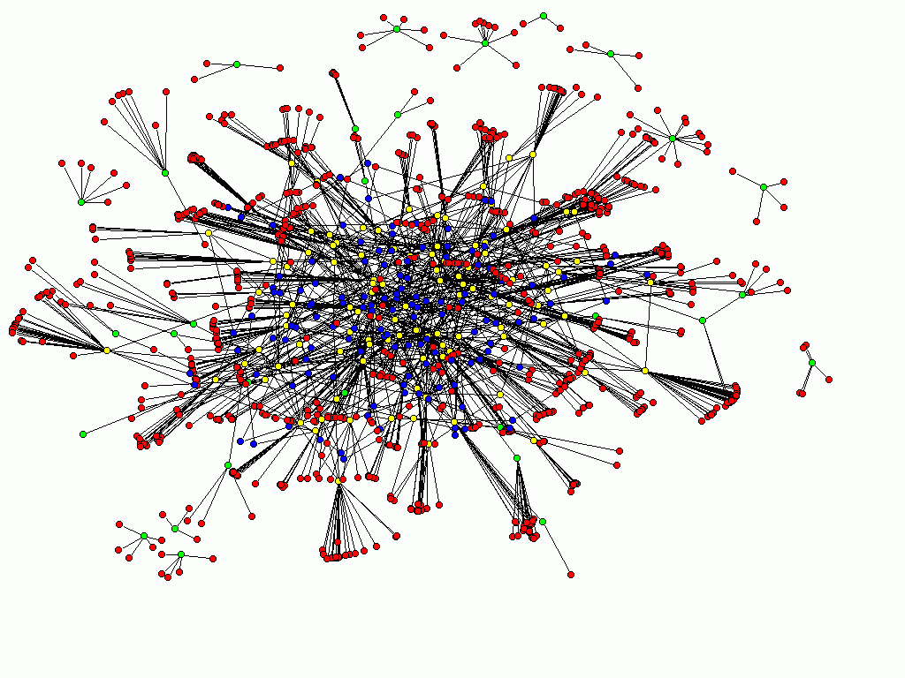
Network theory (tradition of dynamic systems and networks)

A third group - cybersystemic
The third group, active almost exclusively in France, the United States and Germany, and in different ways in each of these countries, relates to systemics and cybernetics, sometimes treating them as if they were one thing. Above all, this results in discursive theories on complex systems. In France, it is the Group of Ten which disseminated cybernetic and systemic concepts also to the general public. This informal club, made up of scientists, philosophers, sociologists and politicians, met regularly in Paris between 1969 and 1976 in the house of one of its members (the doctor and entrepreneur Jacques Robin). The aim of these meetings was to arrive at a new paradigm or a new language useful for both science and politics, which, according to its members,13. If the first two groups are made up of researchers in the natural and social sciences, who mainly produce articles in English where mathematical formalization is quite central, the Group of Ten has notably published books oscillating between philosophy and popularization. Edgar Morin 14and Henri Atlan 15are the most famous and active players in the publication of works on complexity and complex systems, having also had an important influence in the development of the sixty-eight theory of self-management 16
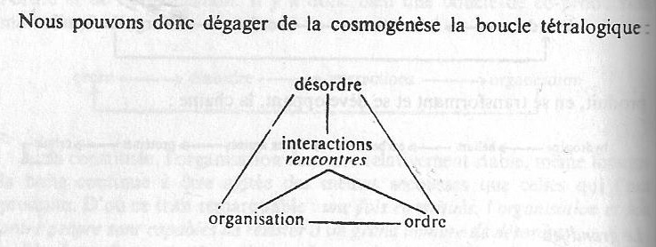
Bloucle de Morin (systemic-cybernetic tradition)
One of the last to join the Group of Ten, the philosopher and historian Jean-Pierre Dupuy, founded in Paris in 1982, with Jean-Paul Dumouchel, the Center for Research in Epistemology and Autonomy (CREA), attached to the School. Polytechnic. Recognized as the first pole of cognitive science research in France, the CREA can also be considered as the first institution dealing with complex systems: but if in the very first years it was through the prism of the approach inspired by cybersystem , little by little the inspired approach of the Santa Fe Institute took over.
- The author would like to thank all members of the GSPR for their reading and advice regarding this post. [ ]
- The GSPR itself was born from questions concerning sociological models and their differential capacities to grasp complex, non-linear or emerging processes, in particular through the socio-informatics study of complex files. On this point, see the program outlined by Francis Chateauraynaud under the title, Pragmatic of complexity. Sociological models for the analysis of mobilization processes (Paris, EHESS, June 2004). [ ]
- Li Vigni, F., Theories of complexity (1970-2010). A sociohistory of an emerging field , Master's thesis in General Sociology, EHESS de Paris, under the supervision of Wolf Feuerhahn, defended in June 2014. [ ]
- Abraham, R.H., « The Genesis of Complexity », World Futures: The Journal of Global Education, 67: 4-5, 2011, p. 380. Internet : http://dx.doi.org/10.1080/02604027.2011.585915. []
- Jean-Pierre Dupuy, the origins of cognitive science , Paris, La Découverte, 1999 (1 ^{st} ed. 1994). [ ]
- Hammond, D., The Science of Synthesis. Exploring the Social Implications of General System Theory, Boulder, University of Colorado, 2003. []
- Aubin, D. & Dahan, A., « Writing the History of Dynamical Systems and Chaos : Longue Durée and Revolution, Disciplines and Cultures », Historia Mathematica, n. 29, 2002, pp. 273-339. []
- Interview with Ralph Abraham, 04/13/13. [ ]
- Delahaye, JP, Random complexity and organized complexity , Versailles, Quæ, 2009. [ ]
- Interview with Jean-Paul Delahaye, 06/02/2014. [ ]
- Waldrop, M.M., Complexity. The Emerging Science at the Edge of Order and Chaos, New York, Simon & Schuster Paperbacks, 1992. []
- Bourgine, P., Chavalarias, D. and Perrier, E., French Roadmap for Complex Systems. 2008-2009 Edition , ISC, RNSC, IXXI, 2009, online: http://www.iscpif.fr/tiki-index.php?page=Roadmap-fr . [ ]
- Chamak, B., Le Groupe des Dix or the avatars of the relationship between science and politics , Monaco, Editions du Rocher, 1997. [ ]
- Morin, E., Method 1. La Nature de la Nature , Paris, Seuil, 1977; Morin, E., Method 2. La Vie de la Vie , Paris, Seuil, 1980. [ ]
- Atlan, H., Organic organization and information theory , Paris, Seuil, 2006 (1 ^{st} ed Hermann Editions., 1972); Atlan, H., Between crystal and smoke , Paris, Seuil, 1979. [ ]
- Rosanvallon, P., The age of self-management , Paris, Seuil, 1976. [ ]

